**Topic: IoT Based Pet Feeder**

**Objective:**

The objective of this project is to create an automatic feeding machine for pets feeding in different time intervals with the help of clock.

**Introduction:**

Automation recently has been a technological revolution in demanded in an industrial scale and also in our daily life gadgets, customers are attracted to

automatic devices more than anything and that is for the purpose of ease in use and time saving, companies are trying to fulfill the demands and the automation industry is becoming stronger and more developed everyday, to be more descriptive automation is a method of controlling and operating procedures in an automatic manner with the help of electronics and software that can be programmed and implemented with machine learning technologies, automation is not very new, it has been there in the market since 1960's when the first ATM machine was introduced, with the help of such machinery the process became much easier faster and more convenient for the customer. Most of the pet owners nowadays want to enjoy the company of their pets, some of the pet owners have the patience and time to feed the pets and some do not

have the time to do so. This is where automation and (IoT) comes in handy to develop a system that can fulfil the pet owner without doing any harm to the

pets. Therefore, previous and recent projects, will be discussed in the literature review chapter, tremendous projects have been designed and released to the market, these automated pet-feeders are functioning to give a fully personalized experience where the pet owner can program the feeding

schedule, where the food can be dispensed at specific timings and with specific quantities, previous researches will be taken into consideration, where it will be opening more chances to understand more and learn from previous experiences and finally to combine the ideas of previous researches to reach to a

point where the system can be enhanced with the most amount of features to make the pet owner satisfied.

learning technologies, automation isn‟t very new, it

**Motivation:**

Pets can severely limit their owner’s freedom by requiring life’s basic necessities: food, water, and shelter. While the latter two are often a non-issue, ensuring they are properly fed remains a constant headache for the average owner. Complications increase when pet owners take vacations and leave their animals behind. The “automatic pet feeder” removes this inconvenience by regulating the quantity and frequency of food delivered while providing user feedback and customization.

**Theory:**

Automated pet feeder is one of the new technologies for feed pet. It will help pet owner to take care of their pet while they are not at home. Even the owners are not at home, they still can feed their pet. Automated pet feeder is built to help pet owner taking care of their pet. Automated pet feeder is one of the pet feeders that will be controlled by a wireless infra-red remote control. The automated pet feeder will be automatically dispenses predetermined amounts of food at the exact times user choose.

**Arduino Uno:** The Arduino Uno is an open-source microcontroller board based on the Microchip ATmega328P microcontroller and developed by Arduino.cc. The board is equipped with sets of digital and analog input/output (I/O) pins that may be interfaced to various expansion boards (shields) and other circuits. The board has 14 digital I/O pins (six capable of PWM output), 6 analog I/O pins, and is programmable with the Arduino IDE (Integrated Development Environment), via a type B USB cable.[4] It can be powered by the USB cable or by an external 9-volt battery, though it accepts voltages between 7 and 20 volts.

**Material Required**

**Hardware:**

* Arduino Uno Board
* Servo Motor
* Thick Wires
* 2 Cans
* Electric tape
* Cutter

**Software:**

Arduino Uno

**Methodology:**

1. Take a can for food storage, make a pivot hole to attach servo motor

adapter and one big feeding hole. Take another bigger can, make similar

pivot hole and a feeding hole. Cut out holes of both the cans.

2. Fit the servo adapter in the pivot hole of food storage can and similarly fit

the servo motor in bigger can.

3. Cut out a smile like part from the lower can and attach a thick paper funnel

to it.

4. Connect the servo motor to the Arduino uno board as given in the circuit

diagram i.e. PWM pin-9, GND pin and 5V pin.

5. Connect Arduino board to the laptop with the help of USB cable and

upload the code to it. Run the code and your automatic pet feeder is ready.

**Pin Diagram:**

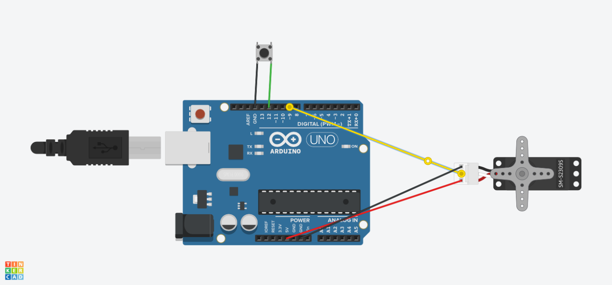

**Applications:**

* This invention can be used to feed dry food, canned food and medication for pets.
* It can also be used by pet owners to reinforce good behavior and also be connected to training and exercise devices.
* The device can be actuated at specific times and or by remote means by the pet owner.